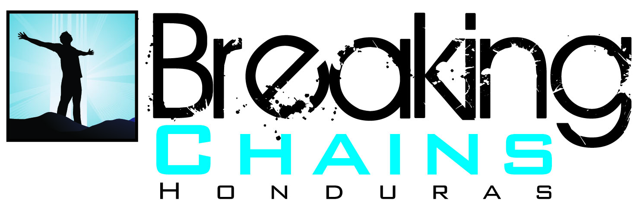

Dear Group Leader,
Thank you so much for the opportunity to share with you a little bit about Breaking Chains Honduras.
Amber Foster established Breaking Chains Honduras in January 2009 as a way to reach out to the marginalized, street population in the capital city of Honduras. The ministry’s mission is to serve and seek change for those affected by urban poverty in Tegucigalpa by meeting basic needs and developing human relationships that act as a gateway toward a relationship with Christ.
On the following pages you will find information regarding how you can participate in the ministry’s efforts, both here in the U.S. and by joining us in Honduras. If you are interested in bringing a mission team please send your anticipated dates and number of people along with your name, email address and phone number to mail@bchonduras.org.
If you have additional questions, please email mail@bchonduras.org and we will respond to you as quickly as possible.
Sincerely,
Breaking Chains Honduras
www.bchonduras.org
www.facebook.com/bchonduras
mail@bchonduras.org
P.O. Box 20454
Oklahoma City, OK 73156
.
How much does it cost to bring a team to Honduras?
General Expenses

Airfare Between $600-$800 per person
Lodging at Baxter Institute $12 per person per night
Breakfast at Baxter Institute $3 per person per meal
Dinner at Baxter Institute $5 per person per meal
Sack Lunch $4 per person per meal
Purified water $1 per person per day
Fast Food Approx. $600 per person per meal
Nice/Authentic Dinner $25.00 or $12-$14 per person (depending on restaurant)
Exit Fee $38 per person
Coordination fee $30 per person
Bus Rental within the city $140 per day (including gas)
Bus Rental outside the city $175 per day (including gas)
26 passenger mini bus $130 per day (including gas)
26 passenger mini bus (outside city) $150 per day (including gas)
Baxter Pickup Truck Rental $50 per day
15 Passenger Van Rental $75 per day
Dump Truck Rental $75 per day
Gas Approx. $4.75 per gallon

Work Related Expenses

Wooden House $1200 per house
Food Bags (usually in sets of 100) $10 per bag
Other work projects have varying costs
VBS Programs Teams usually bring their own supplies but you can also send a supply list and we will do our best to get what you need.
Medical/Dental Clinics Teams should bring their own supplies, but some medicines are available for purchase from the clinic.

What Can We Do While We’re In Honduras?

Local communities of Mateo, Mogote or Ramon Amaya
- Work with the local congregations on their church buildings and other projects
- Hold VBS programs (usually a one day, three hour program held in up to four locations)
- Hold medical/dental clinics
- Build houses for underprivileged families (It usually takes eight people one day to build one house. This will vary slightly based on experience.)
- Distribute food bags to people in need throughout the communities

Breaking Chains
- Hold a Carnival, VBS, or Youth Program
- Clothing/Shoe Drive
- Various work projects around the building
- Feed the Homeless (this is an evening time activity, usually from 7-8 pm)

Jovenes en Camino boys home
- VBS Program
- Various work projects

Feed lunch at the city dump

Visit the special needs orphanage

Additional recreational activities:
- Valle de Angeles: Small town in the mountains, beautiful views and souvenir shopping
- Mi Esperanza: Shopping with a purpose through another local ministry
- Jesus Statue (Picacho): Gardens and large statue of Jesus overlooking the city
- Soccer at Baxter with a local congregation
- Amapala: Overnight trip to a rural beach community
- Roatan: Requires a flight to an island off the coast of Honduras; beautiful resort vacation

How Can We Help From Here?
Breaking Chains
Contribute to our facility’s roof replacement $20,000 needed
Contribute to our administrative needs $30,000 per year needed
Sponsor a teenager’s education $50 per month
Feed 50 people one night a week for a month $200 per month
Feed 50 people for one night $50 per night
Buy someone a pair of shoes $15 (approx. 200 people total)
Sponsor a Clothing Drive
Sponsor a Shoe Drive
Sponsor a First Aid Supply Drive

Prayer
Prayer is our most powerful tool as Christians. Please keep us in your thoughts and prayers as we strive each day to reach out to a community of people who are grossly underserved.

